OCEAN BEACH FIELD TRIP
OCEANOGRAPHY SUMMER SCHOOL
UNIVERSITY OF GHANA, ACCRA
01-Aug-2016

Natural variability I: Swell, wind waves, wave direction, and refraction

The surface waves you see at the beach are created by wind blowing on the surface of the ocean. Waves can be generated by local winds, or by large storms far offshore. The speed at which a wave travels is dependent on its wavelength, with longer waves traveling fastest. How can you tell what waves are local and what waves come from far away? (Hint: try counting the time between successive breakers.)

Wave speed also depends on the depth of the water, with deeper water waves traveling faster. What occurs when a wave approaches the shoreline at an angle? (Hint: Drawing a diagram might help.)

Natural variability II: Surfzone, breaking zone, currents and undertow/rips

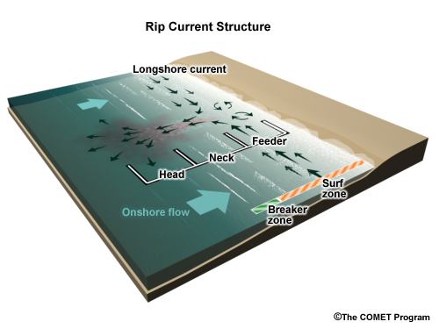
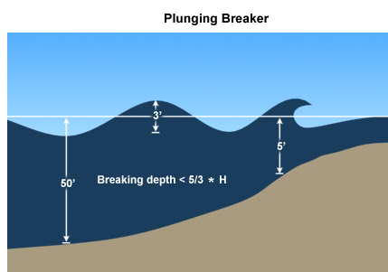

Rip currents form when wave-induced pressure gradients cause converging currents. Rip currents can move sand (and sometimes people!!) rapidly out to sea. See if you can find a rip current. (Hint: rip currents can be recognized by discoloration of the water and foam lines on the surface.)

Natural variability III: Erosion, sand transport

Waves, coastal currents, and tides are responsible for the transport of sand on a beach. Sand can be transported along the beach (this is called the littoral cell) or on- and offshore. On or offshore transport sand transport controls beach slope. Try to get an estimate of the beach slope at different locations across the beach. If the beach was more or less steep, how would the breaking waves change? Use your estimate of the beach slope to estimate the change in the water line given 10 cm of sea-level rise. (Hint: one long stride is one meter. Try to count strides and estimate when you have gone up or down 1/2 meter.)

Human Impact I: Pollution

Humans have a strong impact on our coastal environment. Pollution comes in many forms, and can be found on the land, in the sea, and in the air. What types of pollution do you see and how do you think this pollution could be better controlled?

Human Impact II: Environmental modification and structures

We depend on our coasts for many ecosystem services, including access to natural resources, fisheries, tourism, and leisure activities. To control access to these activities we often need to create infrastructure. What types of man-made structures do you see? And, what are these structures used for?

Beach Experiments: Physical and Chemical Sampling

We will be taking time series measurements of temperature and pressure (depth) of the water. Draw a diagram showing the mooring that is being deployed (i.e., draw a sketch of the float, weight, and location of the sensors). What types of signals do you think you will be able to see in the data? Given the processes that your listed, how fast does the sensor need to sample?

